Chapter 5 Programming

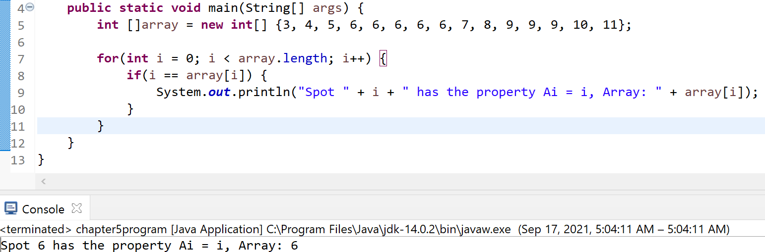**In practice:**

**5.30:** Made the array and had it read linear O(N) through the whole array with a for loop in the for loop I had it check to see if

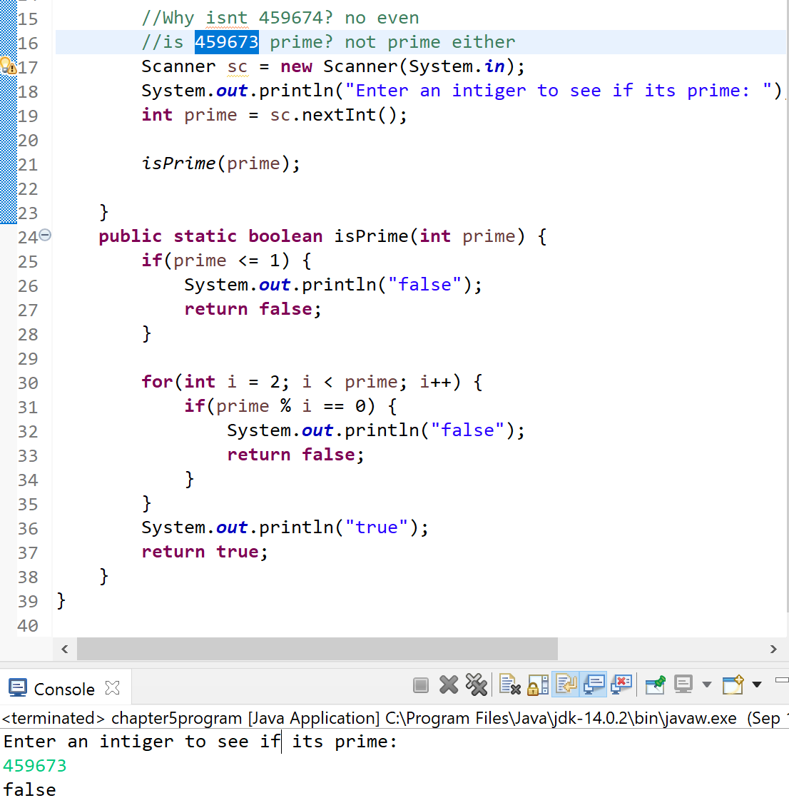Ai = array[i] to check if index and element were the same and if they were then it printed it. It worked.

**5.31 skip b, c, and d:** took in an int from the user with scanner then used a method to pass the number then return a boolean checked to see if the number was less then or equal to and If it was then its false. Then started at 2 and went all the way to the number before the number entered by the user and divided each if the modules are 0 then it divided without reminder being false if not then true meaning it’s a prime number. It worked with what I entered.

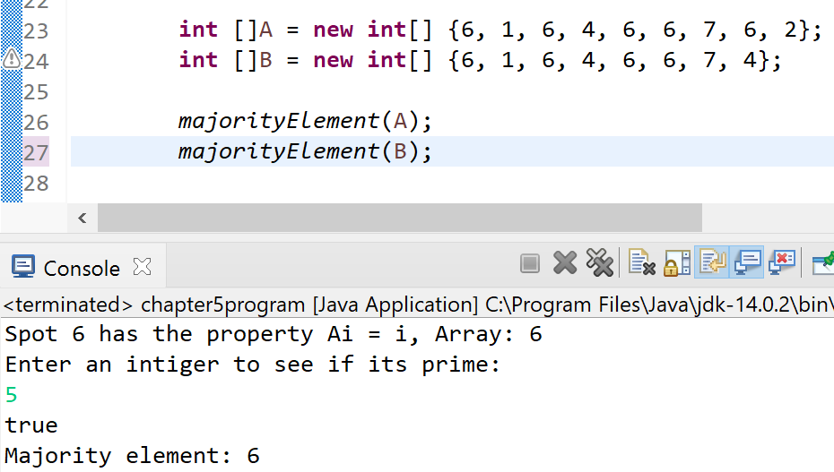**5.33:** Made two arrays to test the majority element I know A has one and B doesn’t. so I made a method to test.

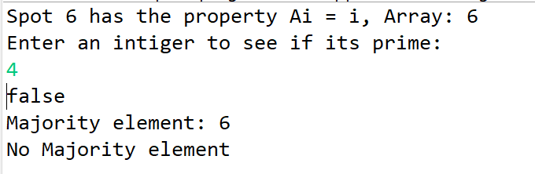

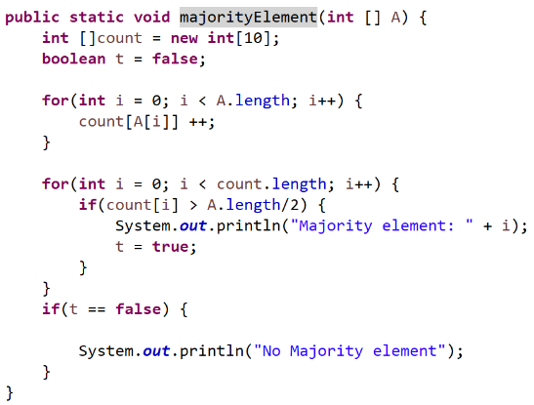here is the method which I did the work of reading the array then printint out which one it was or if it wasn’t. I did this in big oh linear run time. Reading through everything once. It worked how I wanted it too.